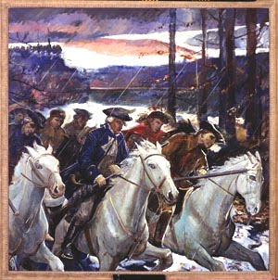
March to the Battle of Kings Mountain
Presented by the
Overmountain Victory Trail Association (OVTA)
Tuesday September 29, 2020
2:00 pm and 7:00 pm
Historic Carson House (Jubilee Arbor)
1805 Highway 70 West, Marion, NC 28752
The program is open to the public and there is no charge.
Please adhere to social distancing and facial covering guidelines.
The program will be presented outdoors in the covered arbor.
For more information contact the Historic Carson House 828-724-4948 historiccarsonhouse@gmail.com
OVTA. org

