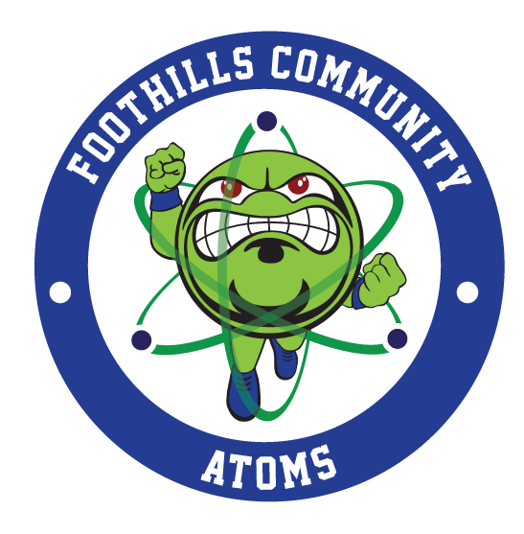

Foothills Community School
Return to School Plan
Aug. 2020
This is a living document, due to new information and guidance that is shared daily, the document will update accordingly.

TABLE OF CONTENTS

SECTION 1: SAFETY OF STUDENTS, STAFF, AND VISITORS 3
SECTION II. ACADEMICS AND HOME-BASED LEARNING 20

Changes to the public health situation over the course of the school year may necessitate changes to this guidance.
INTRODUCTION
We have created this plan to aid in navigating the reestablishment of our school where employees, students, and families feel safe and to reduce the impact of COVID-19 conditions upon returning to the district. The guidelines referenced in this plan are based on guidance from the Centers for Disease Control and Prevention (CDC) and the NC Department of Health and Human Services (NCDHHS). Regular updates will be made to this plan based on information provided by the CDC, NCDHSS, and applicable federal, state and local agencies.
GUIDING PRINCIPLES
In order to ensure the continued wellbeing of our employees the following guiding principles have been put in place:

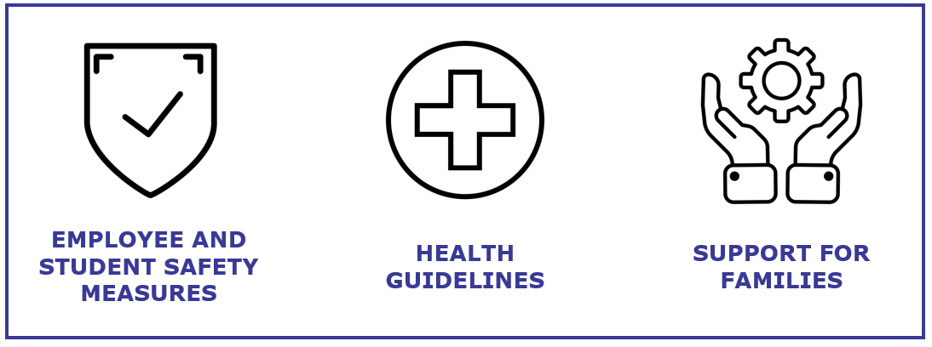

FOUR PRACTICES
FCS will:
- Provide notice to parents of safety precautions.
- Implement practices to help prevent the virus from entering the school.
- Respond to a lab-confirmed case in the school.
- Implement prevention and mitigation practices to reduce the likelihood that an outbreak occurs on campus.

EXPOSURE DEFINED
Close contact of less than 6 feet for more than 15 minutes to a person who has COVID-19 symptoms or a person who has tested positive.

Safety of Staff, Students and Visitors

PHASES AND TIMELINES

PHASE | TIMING | ITEMS
PLANNING | May | - Begin Planning  - Review recommendations of CDC, NCDPI, NCDHHS, and NC Gov.  - Open building for teachers with limited access/use
PREPARATION | June | - PLC in person and virtual for teachers to support PBL for the 2020-21 school year  - Continued planning and recommendation review
PREPARATION | July | - Prepare for possibility of Option B and/or C.  - Begin CANVAS training for administration and staff  - Review recommendations of CDC, NCDPI, NCDHHS, and NC Gov.  - Complete measurements needed for spacing and social distancing  - Review and respond to survey results  - Prepare based on local LEA decisions
Implementation | August | - Summer Bridge  - Ensure Virtual and In-Person plans are shared and understood with staff and families.  - Identify most at-risk/vulnerable  - Host a parent academy for remote support

VISITOR RESTRICTIONS
FCS will limit normal visitation to our campuses at this time. Only FCS employees are allowed on campus during preparation for reopening. All individuals entering the building will be required to wear face coverings (as determined by the Governor's executive order). Individuals proceeding beyond the reception area will be subject to the following guidelines: visitors will be screened, virtual meetings will be available when possible, visitors and staff will maintain physical distancing and proper sanitation for all meetings.
If you are planning to pick up your student early to attend to non-COVID needs, such as doctor appointments, dentist appointments, etc. please give your name and the student name when you arrive at the gate. This will be relayed to the front office so that you child is ready for you when you arrive.
TRAVEL RESTRICTIONS
FCS will discontinue staff travel to conferences and workshops until further notice unless pre-approved by the Human Resource department and the office of the Superintendent. We will minimize non-essential travel throughout the year.

EMPLOYEE AND STUDENT SCREENING AND PROTOCOLS
To help prevent the spread of COVID-19 and reduce the potential risk of exposure to our employees and students, we will be requiring employees and students to be screened prior to or immediately upon entry of the building. This screening will include a temperature check; reading and answering a set of questions related to COVID-19 symptoms including:
- Cough
- Shortness of breath or difficulty breathing
- Chills
- Repeated shaking with chills
- Muscle pain
- Headache
- Sore throat
- Loss of taste or smell
- Diarrhea
- Feeling feverish or a measured temperature greater than or equal to 100.0 degrees Fahrenheit
- Known close contact with a person who is lab confirmed to have COVID-19
All screening information will be kept confidential by Human Resource and the district nurse. Teachers and staff must report if they themselves have COVID-19 symptoms or are lab-confirmed with COVID-19, and, if so, they must remain off campus until they meet the criteria for re-entry. Additionally, staff must report if they have had close contact with an individual who is lab-confirmed with COVID-19, and, if so, must follow the NCDHHS flow chart and guidance. The complete guidance can be found: https://files.nc.gov/covid/PHT-ScreeningReferenceGuide_6.30.pdf
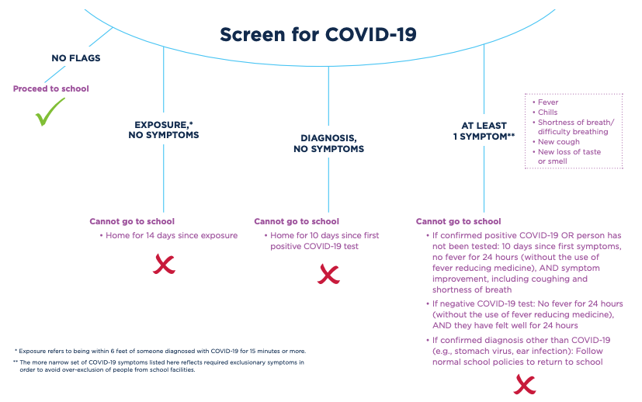
SCREENING PROTOCOL
Parents must ensure they do not send their student to school if the child has COVID19 symptoms or is lab-confirmed with COVID19, and instead should opt to receive remote instruction until the conditions for re-entry have been met. Parents may also opt to have their child receive remote instruction if their child has had close contact with an individual who is lab-confirmed with COVID19 until the 14-day incubation period has passed and/or has a negative COVID test. If a parent sees that the student cannot go to school based on the criteria above, please notify the school.
BEFORE COMING ONTO CAMPUSES OR BUSES
At the beginning of the year and the start of on-campus instruction, FCS will screen students to determine if (a) they have the COVID-19 symptoms; or (b) they have had close contact with an individual who is lab-confirmed with COVID-19. Screening is accomplished by asking questions in person. If the parent is dropping off or picking up a student, the screening questions will be asked to the parent. FCS is permitted to prevent any individuals who fail the screening criteria from being admitted to the campus or a bus until they meet any of the criteria for re-entry to the campus.

TRANSPORTATION CHECKLISTS
Bus drivers will take temperatures and ask screening questions prior to students getting on the bus. All surfaces must be cleaned with a disinfectant solution prior to student loading. Bus drivers will wear masks or shields at all times. The driver’s temperature must be checked and documented before the start of each route.
If a student is unable to load the bus due to elevated temperature (100.4 F) the student must return home and a guardian will be contacted.
HANDOUT: TRANSPORTATION SANITATION CHECKLIST
- Hand sanitizer will be at the entry of all buses.
- Students may sit one to a seat unless it is a family member.
- When possible, windows will be open to allow outside air to circulate throughout the bus.

HEALTH PROTOCOL
If an employee becomes ill at work or if another person is exhibiting symptoms of COVID19 at work, they may be asked to leave work and go home or to the nearest health center.

TESTED POSITIVE FOR COVID-19 or SUSPECTED WITH COVID-19
Any individuals who themselves either: (a) are lab-confirmed to have COVID19; or (b) experience the symptoms of COVID19 must stay at home throughout the infection period, and cannot return to campus until the school system screens the individual to determine any of the below conditions for campus re-entry have been met:
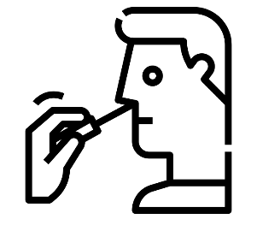
Return to work/school criteria:
- At least 3 days (72 hours) have passed since recovery (no fever without the use of fever-reducing medications); and
- You have improved in respiratory symptoms (cough, shortness of breath, etc); and
- At least 10 days have passed since symptoms first occurred

If you have symptoms that could be COVID19 and do not get evaluated by a medical professional or tested for COVID19, it is assumed that you have COVID19 and may not return to work/school until the three criteria listed above have been met.
If the individual has symptoms that could be COVID19 and wants to return to school before completing the above stay at home period, the individual must obtain a medical professional’s note clearing the individual for return based on an alternative diagnosis.

IDENTIFYING POSSIBLE COVID19 CASES ON CAMPUS
FCS will immediately separate any student into a supervised isolation room who shows COVID19 symptoms while at school until the student can be picked up by the parent or guardian.
FCS will clean the areas used by the individual who shows COVID19 symptoms while at school (student, teacher, or staff) as soon as feasible.
Students who report feeling feverish should be given an immediate temperature check.

PRACTICES TO RESPOND TO A LAB CONFIRMED CASE IN THE SCHOOL

GUIDANCE IF EXPOSED
While we all hope to avoid exposure to illness from COVID19, we need to be prepared for that possibility. If you or someone you’ve been in contact with has been exposed to the virus, our first concern is for your health and safety and those around you. In this rapidly changing situation, healthcare providers should have the most up-to-date information from the CDC.
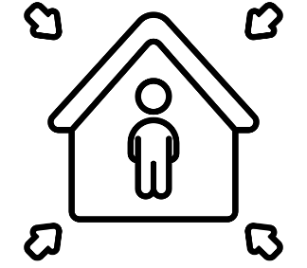
Please do the following:
- Quarantine yourself in a specific room away from others in your home
- Contact the following (in order of priority), let them know you have been exposed to COVID19, then follow their instructions.
  - Your healthcare provider
  - Mrs. Shaver, Principal of FCS
- Mrs. Shaver will work with HR (if staff member) to determine appropriate next steps.
- In case of an emergency, call 911 and let them know you have been exposed to COVID19, then follow their instructions.
- FCS requires the student, teacher, staff, or visitor to stay at home through the 14 day incubation period and will not be allowed on campus. If the individual experiences symptoms, they must stay at home until the conditions outlined below have been met.
  - At least 3 days (72 hours) have passed since recovery (no fever without the use of fever-reducing medications); and
  - You have improved in respiratory symptoms (cough, shortness of breath, etc); and
  - At least 14 days have passed since symptoms first occurred

SOCIAL DISTANCING
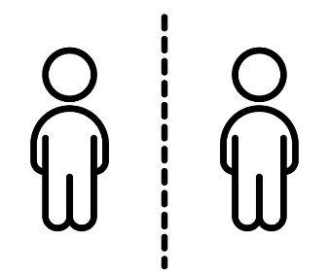
Social distancing is an effective way to prevent potential infection. FCS employees, students, parents, and visitors should practice staying approximately 6 feet away from others and eliminating contact with others.
Traffic Flow – Taped lines on the floor will mark the walking direction throughout the office in order to maintain the social distancing requirement of 6 feet and/or cones in the halls will determine distancing

Ad-hoc Interactions/Gatherings – Non-essential/informal meetups and visiting should be avoided or individuals separated throughout the space.

PERSONAL PROTECTIVE EQUIPMENT (PPE)
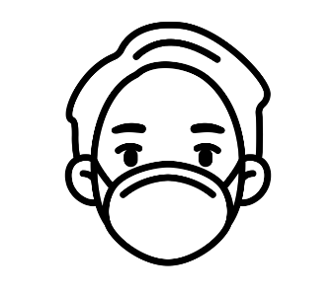
In order to minimize exposure to COVID-19, students, staff and visitors will be required to wear a cloth face mask that covers the mouth and nose daily.
Masks: Face masks are an important part of everyone's protection, as well as personal hygiene, social distancing, and frequent cleaning efforts. Schools are required to comply with the governor’s executive order regarding the wearing of masks.
Students can provide their own face masks, but several will be provided to your students. Students and staff must wear their face masks throughout the day when they are in the school building and while on the bus. If parents and students do not want to wear masks, the virtual option is available.
Gloves: Some staff members will be wearing gloves. Wearing gloves does not diminish the need to wash your hands. Please remember to wash your hands properly as it is the number-one defense against the spread of infection. Additionally, the proper removal of gloves reduces the risk of being exposed to contamination.
In addition to using PPE, please remember to:
- Wash your hands often with soap and water for at least 20 seconds. Use hand sanitizer with at least 60% alcohol if soap and water are not available
- Avoid touching your eyes, nose, and mouth
- Cover your mouth and nose with a tissue when you cough or sneeze or use the inside of your elbow

PERSONAL WORKSPACE/CLASSROOM
FCS staff will disinfect and sanitize between family and content seating. Employees are encouraged to disinfect their own personal workspace (teacher desk, phone, etc) throughout the day, giving special attention to commonly touched surfaces.
Between family and content seating, teachers will spray disinfectant on empty space. No seat will be utilized twice during the day.
At the end of the day, the teacher will wipe down (while wearing gloves and mask) the doorknob and all seating.

MAXIMUM CAPACITY PER CLASSROOM AND RESTROOM
FCS 009-Hunt- 15
FCS 011- Gramer- 15
FCS 012- Yergler- 15
FCS 001- Meaney- 15
FCS G10-Powell- 15
FCS G016- Shaver- 5
FCS- G1- Tyler- 13
FCS G2-Gunter- 14
FCS G3- Braswell-12
FCS G11- Carpenter-13
FCS Bathroom-
Boys- 2
Girls- 2
WMMS 8th Grade Hallway-
Boys- 2
Girls- 2

SHARED WORKSPACE
Employees are encouraged to disinfect their own workspace multiple times throughout the day, giving special attention to commonly touched surfaces. FCS has alcohol-based hand sanitizers throughout the workplace and in common areas. Cleaning sprays and wipes are also available to clean and disinfect frequently touched objects and surfaces such as telephones and keyboards.
Please note that proper equipment such as acceptable disinfectant and PPE should be used when cleaning individual workspaces.
There will be limited access to certain workspaces to reduce exposure to risks and ensure employee safety. Workspace usage is as follows:
- Capacity – FCS will be monitoring the number of students and staff in the rooms while the risk of infection exists.
- Shared Appliances –Such as microwaves will be unavailable for use.

FACILITIES CLEANING
The safety of our employees and students is our first priority. Upon reopening, our schools have been completely cleaned and disinfected and we will continue to adhere to all necessary safety precautions. In addition to the deep clean of the office and school before employees and students return, the cleaning steps outlined below are to be taken to disinfect workplace surfaces, chairs, tables, etc. to protect employees and reduce the risk of spread of infection. We will require employees to maintain this safety standard by continuously cleaning and disinfecting based on the frequency stated below.

GENERAL DISINFECTION MEASURES
Category | Area | Frequency
WORKSPACES | Classrooms, Offices | At the end of each use/day
ELECTRONIC EQUIPMENT | Copier machines, Shared computer monitors, TV’s, Telephones, keyboards | At the end of each use/day and/or between use
GENERAL USED OBJECTS | Handles, light switches, sinks, restrooms | At least 4 times a day
BUSES | Bus seats, handles/railing, belts, window controls | At the end of each use/day
COMMON AREAS | Cafeteria, Library, Conference rooms, Gyms, Common Areas | At the end of each use/day; between groups

The goal is to establish a sanitary baseline before the site opens. The site should be 100% disinfected prior to anyone returning to work.
GENERAL DISINFECTION MEASURES PROTOCOL
General measures should be followed regularly. FCS will institute more frequent cleaning practices.
- Desks will be cleaned utilizing CDC approved disinfectant spray after family seating and after content area seating.
- At the end of the day, each desk will be wiped down with disinfectant.
- Door Handles and commonly touched items will also be wiped down with disinfectant daily. The use of door handles will be limited due to open doors to support air movement.

DEEP CLEANING AND DISINFECTION PROTOCOL
Deep cleaning is triggered when an active employee or student is identified as positive for COVID19 based on testing. Deep cleaning should be performed as soon as the confirmation of a positive test, as practical.
- FCS will close off areas that were heavily used by the individual with the lab-confirmed case (student, teacher, or staff) until the non-porous surfaces in those areas can be disinfected, unless more than 3 days have already passed since that person was on campus.
- Notification: FCS will follow the guidelines for reporting lab-confirmed cases of COVID19 with the processes set in place by our local health department.
SIGNAGE
Signage will be placed throughout the offices and school, to notify students and staff of directional movement and maximum capacity of rooms.

FOOD DELIVERY
Bringing or sharing refreshments during meetings is prohibited in order to limit the risk of contamination. We ask that there be no food delivered and that food be kept at your assigned space. Our cafeteria staff offer daily, hot meals.
Now you can apply on-line for your children to receive free or reduced price school meals. Your application will be sent from a secure web site directly to the McDowell County Schools Nutrition office, so you don’t need to worry about filling out a paper form that could be lost or misplaced.

LunchApplication.com is an easy, secure and convenient way to apply for free or reduced meals. It has been designed to make it easy for you to know exactly what information you need to provide and to guide you through the process. Once your application has been received the district office will determine your eligibility and send you a letter with the results.

To apply, simply go to LunchApplication.com or CLICK HERE to apply now!

PRACTICES TO MITIGATE THE LIKELIHOOD OF COVID19 SPREAD INSIDE THE SCHOOL
- FCS will have hand sanitizer and/or hand washing stations with soap and water in classrooms.
- Students, teachers, staff, and campus visitors will be encouraged to sanitize and/or wash hands frequently.
- Confirm school district has an adequate supply of soap, disinfection, hand sanitizer, paper towels, and tissues
- Confirm a supply of gloves and other protective gear
- Touchless thermometers on-site for employee and student screening
- Staff and students will maintain social distance guidelines.
- All students will wear masks that cover their mouth and nose, unless otherwise specified by a doctor.

STUDENT AND TEACHER GROUPINGS
For a Plan B option, students will be divided into three groups.
Electrons: This group will start in person on Week 2 and alternate weeks.
Protons: This group will start remote on Week 2 and alternate weeks.
Neutrons: At home, virtual learners. Virtual learners will need to attend an online orientation Aug. 10th.
**Electrons and Protons will be divided by bus routes, this will be sent and published as soon as they are received.
During Week 1 (Aug. 17-24) FCS will host all students at a 20% capacity each day.
- Students will learn
  - Canvas
  - Health orientation
  - Social Distancing procedures
  - Classroom and Google Meet norms.
To ensure that families have expressed their needs, we will complete a commitment form for virtual or in-person learning, this informs our scheduling.
Hard copies: https://drive.google.com/file/d/1vpX3cQ2QqEDtVibCVwd7FJGsEbGCNnMZ/view?usp=sharing
Online: https://forms.gle/9kXL9fLT3wsv75Cu5
McDowell County School Board has approved Plan B:
Schedule of 25% was agreed upon in a Leadership meeting on 7/28/2020.

PLAN B
Grades 2-12/13 Students

 | Monday | Tuesday | Wednesday | Thursday | Friday
Week 1  Students will be divided into five groups to attend school on a rotation basis | 25% of students on campus for orientation | 25% of students on campus for orientation | 25% of students on campus for orientation | 25% of students on campus for orientation | Staff Planning and Logistics  Remote Day
Week 2 and beyond | Alternating Weeks  Week 2: Group A (Electrons) students on campus with Group B (Protons) remote learning  Week 3: Group B (Protons) students on campus with Group A (Electrons) remote learning  (At Risk for learning, connectivity, and social emotional students with needs will have the option to attend daily)
*Week 1 will be a time to create a sense of classroom community, establish protocols and expectations for safety and sanitation while in the school building. This time will allow teachers the ability to orient students to the learning management system, monitor attendance, monitor transportation, and practice operational procedures.

ENTRY AND EXIT
Campuses will plan for entry, exit, and transition procedures that reduce large group gatherings (of students and adults) in close proximity.
Foothills Community School students that are car riders will be dropped off in the south lot. Before students exit the car they must complete the attestation/question screener and have their temperature checked.
All staff will enter through the FCS door for screening.
To enter the building from the South Lot, students will follow the sidewalk around to enter in the FCS door.
Foothills Community School students that are bus riders will be dropped off in the north lot and enter through the courtyard doors.
When students arrive at the school they will immediately report to their family classroom.
Foothills Community School students will be dismissed in the south lot.
Please be aware of new pick up patterns and expectations.
Student’s names will be called out and students will go to the letter called sign for pick-up.

STUDENT ARRIVAL AND DISMISSAL
We ask that parents avoid early drop offs in the mornings, the school will not be opened until 7:10am. Students who arrive by car will enter through the FCS hallway or by bus through the courtyard door. Students will go directly to their family classroom. Staff and students must wear masks upon entry and at dismissal.
Students riding the bus will have their temperature taken prior to loading. Please ensure that if your student has a fever that they are able to return home.
Students that are car riders will have their temperature taken before exiting the vehicle. Students will stick their heads out of the car window to allow their temperature to be taken.
SAFETY SUPPLIES
The district/state has purchased/obtained several safety items:
- Touchless Forehead Thermometers
- Face masks
- Nitrile Powder Free Gloves
- Limited Plexiglass Acrylic Countertop Shields - offers protection from sneezes and coughs during person-to-person interaction at front desk station.
BUS DRIVERS/BUS PROTOCOLS
Bus drivers or custodial staff must disinfect the buses at a minimum:
- Right before starting a route to pick up students
- Right after the morning and afternoon routes
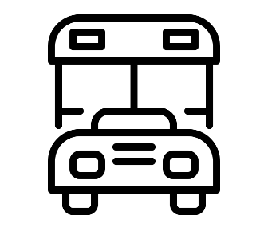
Bus drivers must not report to work if they suspect they are sick or if they have symptoms such as fever or difficulty breathing, or have been in contact with other people who have any confirmed respiratory illness or disease the last 7 days. MCS will place hand sanitizer at the entry of all buses. When possible, windows will be opened to allow outside air to circulate the bus. .

COVID19 CASE FORM
If an employee or student becomes ill on campus/district, he/she will immediately report to the school nurse’s isolation room and the case log will be completed.
Once the employee or student arrives at the isolation room, immediately provide them with a mask and gloves. Explain that this is to help protect other employees and students and prevent the spread of the potential virus.
- The nurse must complete the Suspected COVID19 Log and call the local health department according to NCDHHS guidelines and follow any instructions received.
- The nurse and others attending the suspected infected person, should also wear a protective mask and gloves while working with the suspected infected person.
- The nurse will direct the ill employee to leave work or call the parent of the student to be picked up and go home.
- The nurse and campus/district supervisor must identify persons who may have come in contact with the suspected infected person. The nurse will provide required information to the health department whether it is a student or employee following GS130A-136 and 130A-143.
- Advise employees that they may have been in contact with a suspected employee and to carry out self-screening every morning, and based on the results, contact the health department.
- The isolation area and suspected employee’s or student’s work area/classroom must be thoroughly cleaned and disinfected, in addition to all other common surfaces recently touched by the employee or student.
RESTROOM USAGE DURING THE WORKDAY
Establish maximum capacity for the facility that allows for social distancing. Post the maximum capacity sign on the door. All bathrooms are equipped with soap, warm water and paper towels.

RESTROOM CAPACITY
FCS Bathroom-
Boys- 2
Girls- 2
WMMS 8th Grade Hallway-
Boys- 2
Girls- 2

VISITORS ON CAMPUS
The safety of our staff and students remains the district’s primary concern. To help prevent the spread of the virus and reduce the risk of exposure to our staff and students, visitation will be limited. We do realize that visitation occasionally is needed so we are conducting a simple screening questionnaire. Participation is important to help us take precautionary measures to protect you and everyone in the building. FCS will restrict visits to the school to only those essential to school operations. SCREENING FORM

CAFETERIA AND MEAL PERIODS
Students may bring their own meals or be served individually plated meals. At this time, the plan is for students to eat in the room or outside.
No parents/visitors during lunch are allowed at this time. Cafeteria staff will be trained in COVID-19 safety protocols. Classes will go to lunch on a staggered schedule to minimize the number of students in the cafeteria each period. All cafeteria staff will be wearing masks and gloves while serving students. High touch surface areas will be disinfected between service periods and use.
FCS will utilize outdoor picnic spaces (weather permitting) and common areas of the buildings to allow for adequate dining space.

MODIFIED SCHEDULE AND MOVEMENT
Students will only move classrooms twice throughout the day in a staggered fashion. This reduces the amount of contact while still maintaining Family support and Content support. Desks will be marked with either family seating or content/instructional seating and no desk will be used twice in the same day. This prevents cross contamination of resources and materials. Students will be spaced in seating areas that are 6 ft apart to accommodate social distancing.
Because of these safety guidelines the schedule does look different than in years past.
The official start time is 7:45am and official end time 2:15 pm.
7:10-8:00 Breakfast in the Classroom/Academic Support Time-Family Seating
8:00-8:40 FCS Elective (with Family Group)- Family Seating
- 2 Week Rotation (A/B groups each get a face to face)
8:40-9:40 Family- SEL/Project Time-Family Seating
9:45- 10:45 Instructional Block (1st Content)- Content Seating
10:45- 11:15 Lunch in the Classroom- Content Seating
11:15-12:15- Instructional Block (2nd Content)- Content Seating
12:15-1:15- Instructional Block (3rd Content)- Content Seating
1:15- 2:15- Instructional Block and Dismissal (4th Content)- Content Seating
Safety and Cleanliness
1. Disinfectant, cleaning and bathroom breaks will be built in.
2. Classrooms have Family and Content Seating so that no one is sitting in the same desk as someone else.
Notes:
Bathroom times will be staggered.
Only 2 teacher movements due to combined Sci/SS classes in 6th and 7th grade.

SOCIAL-EMOTIONAL WELL-BEING OF STUDENTS AND STAFF
Social Emotional Learning (SEL) is important to the staff and administration at Foothills Community School. Providing a well established understanding of self, teamwork, perseverance, and decision making is critical to adolescent development. Time for this will be built into our schedule on a daily basis.
STAFF AND STUDENT TRAINING
- Pre-Return to School Training - Presented remotely to staff to ensure understanding and preparedness to align with this manual
- Staff First Day Training/Orientation - Align local protocols and procedures with this manual; meeting areas must adhere to social distancing protocols or present via digital platforms such as Google Meet.
- Student First Day Training/Orientation: On the first day of school, FCS will provide instruction to students on appropriate hygiene practices. Students will be aware of all expectations and routines outlined in this plan.
- Parent Academies - Online and in-person (with masks and social distance guidelines) will be provided to support at home and remote learning.
It is very important that all employees, students and parents understand the safety requirements, protocols and expectations to ensure everyone and their communities stay safe and prevent the spread of the virus.

COMMUNICATION METHODS
To stay updated on the most up-to-date information:
- Teachers, students, and parents need to check their email often.
- Visit our school website https://fcs.mcdowell.k12.nc.us/
- Follow our social media platforms https://www.facebook.com/FCSSTEM/
- Canvas 6-13; Google Meet
- Weekly Newsletters are sent to each email address we have on record and posted on social media. For the 2020-21 school year these will be sent on Friday afternoon.
- Weekly ParentLink phone calls will go out to families, Sunday evening at 7:00pm.
- Each teacher will also have a Remind account to alert parents of due dates and important information.
  - FCS School- Mrs. Shaver: @STEMFCS
  - Mrs. Braswell
  - Mrs. Carpenter
  - Coach Gardin
  - Mrs. Gramer
  - Mrs. Gunter
  - Mr. Hunt
  - Mrs. Meaney
  - Mrs. Powell
  - Mrs. Tyler
  - Mrs. Yerger

Section 2: At Home and In-Person Academics

Foothills Community School staff has been communicating and working hard throughout the Spring and Summer to organize and develop systems in place for the schools reopening. As a whole, our staff meets regularly every Tuesday afternoon.
We have been working on the following items:
- Professional Development
  - Explore Professional Development
    - Supports remote/blended learning
    - Supports project based learning competencies
  - To this point teachers have been trained in
    - Canvas
    - Content Specific Areas
    - MTSS
    - Project Based Learning refresher and planning
    - Priority Standards and supporting standards
    - Read180, Math180, and Orton Gillingham to support targeted academic interventions.

- Instructional Support
  - Re-entry Plan: We will gather data from diagnostic, baseline assessment to ensure targeted student support for the 2020-21 school year.
  - Instructional Gaps: We will take the data from the baseline assessment to determine where the gaps are with each student. Since students did not receive in person instruction during Spring 2020, we expect there may be some learning gaps that will need to be addressed.
  - Scope and Sequence: Since we will not be starting out like a normal school year, our scope and sequence will look a lot different. We will need to integrate previous grade level standards with our Beginning of Year instruction. We will work with our district accountability director to utilize the instructional and assessment tools provided by NCDPI.

- Facility, Safety, and Security Committee
  - Weekly brainstorming to support the safety of staff and students.
    - Plan for movement
    - Schedule for student and staff health and safety
- Social Emotional Learning
  - Working with our counselor and social worker we have identified topics of discussion for the re-entry to school and work.

PARENT COMMITMENT
Parents will be asked to commit to either on campus or remote instruction no earlier than two weeks before the start of the school year (Aug. 3). For a Plan B option, students will be divided into three groups.
Electrons: This group will start in person and alternate weeks.
Protons: This group will start remote and alternate weeks.
Neutrons: At home, virtual learners.

To ensure that parents have expressed their needs, we will complete a commitment form for virtual or in-person learning.
Hard copies: https://drive.google.com/file/d/1vpX3cQ2QqEDtVibCVwd7FJGsEbGCNnMZ/view?usp=sharing

Online: https://forms.gle/9kXL9fLT3wsv75Cu5
ELECTIVES
Although we think student choice is very important, it is critical to ensure that students have access to electives. Students will engage on a 2 week rotation with every elective teacher.
GRADING POLICY
Grading and Attendance
To receive credit and attendance for the courses for this school year students are expected to complete the assignments. The grading policy is located in our campus handbooks. Grading policy will be the same for home learning as it is for on-campus learning.
Completion Protocols
Students not making progress, not completing academic assignments or opting not to participate during the school year, will be contacted by Mrs. Shaver and/or our school social worker Mrs. Fretwell. For promotion to the next grade level, students will need to have completed the requirements for class and receive a 3 or higher.
RECEIVING AND RETURNING STUDENT WORK IF DISTRICT CLOSES
In the event that the school does not reopen or has to close in 2020-2021, we will follow the guidelines below for receiving and returning student work.
The district will use Canvas for grades 6-13. Our school regularly communicates through Parent Link, Canvas, Remind, Facebook and our Webpage. If the family is able to access the internet, effectively all activities should be done online, which will eliminate any public health risk associated with providing instructional support. Multiple hot-spots and free wifi locations are located throughout the county. During instructional training on the first day/week, students will be taught how to download and work on assignments offline to be turned in when wifi is accessible.
PATHWAYS FOR ONLINE INSTRUCTION
The framework below outlines two primary pathways for the school and families to assess and evaluate.
- Pathway 1: Students and Staff Return On Time and On Campus August 17 - We are preparing for re-entry. The buildings, classrooms, and teachers are preparing instruction and safety protocols for our students to be on campus. Pathway 1 means students will return to the classroom on August 17 depending on closure orders from national, state, or local agencies. Having all students on campus is our goal. It is the best instructional approach allowing us to meet student needs- academically, socially, and emotionally.
- Pathway 2: Remote Learning (Technology Required)
  - Synchronous Instruction
    - Two-way, real-time, virtual instruction between teachers and students.

    - Students who are not logged into the class are marked absent. Truancy is monitored. Grading policy will be consistent with those used on campus and in the handbook prior to COVID-19 for all assessments and assignments. Teachers will address the same required curriculum as being presented in the classroom.
  - Asynchronous Instruction (Only for students with Connectivity Issues during remote week)
    - Not live or in person; pre-recorded lessons; students complete work on their own; self-guided using tech devices. Students not engaged in daily lessons will be marked absent. Engaged is defined by FCS as progress in the district’s learning management system (Canvas), progress from teacher-student each day; and assignments are turned in daily. Grading policy will be consistent with those used on campus and in the handbook prior to COVID-19 for all assessments and assignments. Teachers will address the same required curriculum as being presented in the classroom.
TECHNOLOGY DEVICES AGREEMENT
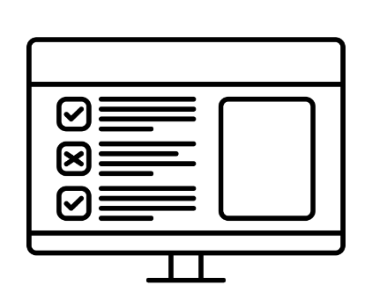
Technology devices will be issued to families requesting a device and completing the FCS Virtual Orientation for Technology Use. This form outlines the acceptance and agreement to adhere to the guidelines and responsibilities of the device protection plan. If the device is lost or deemed to be damaged due to negligence as defined by school administration, replacement and/or repair cost may be assessed.

CHROMEBOOKS
Students in 7th and 8th grade should still have their chromebooks from 2019-20 (unless you have turned in for repairs). 6th graders will receive Chromebooks on Aug. 4 and Aug. 6th during summer bridge.

“
”

