AWARD PRESS RELEASE
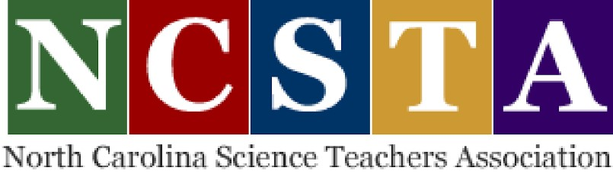
NCSTA
Alisa B. Wickliff
2021NCSTA Awards Committee
704-687-8818 abwickli@uncc.edu

FOR IMMEDIATE RELEASE
Renata Crawley, West Marion Elementary School, wins the NC Science Teachers Association (NCSTA) District 8 Outstanding Elementary School Science Teacher for 2021
Marion, NC, October 18, 2021 – Renata Crawley will be presented with the 2021 NCSTA District 8 Outstanding Elementary School Science Teacher Award at the annual 52nd NCSTA Awards Ceremony, Thursday, November 4, 2021. The virtual ceremony will take place November 4th at 4:00 pm. There is no cost for registration at ncsta.org. Registration is required to attend.
The NCSTA District Outstanding Science Teacher award is given to a person exhibiting leadership in science education; contributing to improvements in science education; and excelling in the aspects of science education. This honor is determined Renata Crawley’s professional excellence and contributions to science education in North Carolina.
Ms. Crawley is one who not only does a great job in the classroom but also leads outside of it and is one of our district champions for experiential science. She has long been both an advocate for and practitioner of getting students up and involved by doing science, not just passively learning the subject. She exemplifies what one wants to see in a master teacher. Her enthusiasm for education is inspiring, her energy contagious, and her passion for students serves as an example for others to follow. When people speak of a favorite teacher, Ms.Crawley’s name is at the top of the list. Mark R. Garrett, Superintendent, McDowell County Schools

Congratulations!

